**PROBLEM STATEMENT:**

Assume a machine has a single register and six instructions:

LDA A Places an operand A into the register

STA A Places the contents of the register into the variable A

ADD A Adds the content of variable A to the register

SUB A Subtracts the contents of the variable A from the register

MUL A Multiplies the contents of the register by the variable A

DIV A Divides the contents of the register by the variable A

Write a program that accepts a postfix expression as a pointer variable containing single letter operands and the operators +, -, *, / and prints the sequence of instructions to evaluate the expression and leave the result in the register. Use variables of the form TEMPn as temporary variables. For example using the postfix expression ABC*+DE-/ should print the following

LDA B LDA D

MUL C SUB E

STA TEMP1 STA TEMP3

LDA A LDA TEMP2

ADD TEMP1 DIV TEMP3

STA TEMP2 STA TEMP4

**PROGRAM CODE**

#include<iostream.h>

#include<conio.h>

#include<string.h>

void mod(char post[1][15])

{

char stck[15],a,b,x,count='0';

int i=0,top=-1;

while(post[0][i]!='\0')

{

if((post[0][i]!='+')&&(post[0][i]!='-')&&(post[0][i]!='*')&&(post[0][i]!='/'))

{

top++;

stck[top]=post[0][i];

goto next;

}

else

{

x=post[0][i];

b=stck[top];

top--;

a=stck[top];

top--;

}

if(x=='+')

{

count++;

cout<<"LDA "<<a<<endl;

cout<<"ADD "<<b<<endl;

cout<<"STA "<<count<<endl;

}

else if(x=='-')

{

count++;

cout<<"LDA "<<a<<endl;

cout<<"SUB "<<b<<endl;

cout<<"STA "<<count<<endl;

}

else if(x=='*')

{

count++;

cout<<"LDA "<<a<<endl;

cout<<"MUL "<<b<<endl;

cout<<"STA "<<count<<endl;

}

else if(x=='/')

{

count++;

cout<<"LDA "<<a<<endl;

cout<<"DIV "<<b<<endl;

cout<<"STA "<<count<<endl;

}

top++;

stck[top]=count;

next:

i++;

}

return;

}

int main()

{

char post[1][15];

cout<<"Please enter the postfix expression (including +,-,* and / only): ";

gets(post[0]);

mod(post);

getch();

return 0;

}

**OUTPUT:**

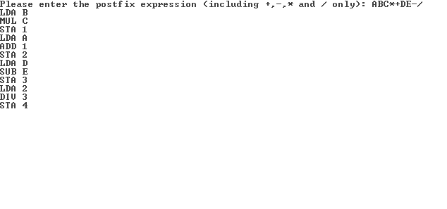

**RESULT:**

This program is written to accept a postfix expression, convert it to assembly level and display the instructions to be given to the assembler for further manipulation.